Protocol for the Collection of Shellfish under the Microbiological Classification Monitoring Programme

Version 11
November 2021

13 Pages
Document prepared by: | L. Coates | Cefas | Classification: Not classified
Document quality checked by: | S. Hart | Cefas | Review Date: N/A
Document approved by: | A Younger | Cefas | Date: 17/11/2021

The Centre for Environment,
Fisheries & Aquaculture Science
Weymouth Laboratory
Barrack Road
The Nothe
Weymouth
Dorset, DT4 8UB
Food Standards Agency London
0330 332 7149
Shellfish@food.gov.uk

Food Standards Agency Wales
02920 678940
shellfish.wales@food.gov.uk
Tel +44 (0) 1305 206600
Fax +44 (0) 1305 206601
www.cefas.co.uk

Cefas is an executive agency of Defra

1. Introduction

The monitoring programme for the microbiological contamination of bivalve molluscs is a requirement of Retained Regulation (EC) No 2019/627 laying down specific rules for the organisation of official controls on products of animal origin intended for human consumption. This legislation requires production and relay areas to be routinely monitored and classified according to the level of faecal contamination in live bivalve molluscs harvested from these areas.

The Food Standard Agency is the Central Competent Authority (CCA) with overall responsibility for the microbiological monitoring programme in England and Wales. Cefas is contracted to coordinate this programme. Local authorities (LAs) act as the Competent Authority (CA) responsible for sampling classified production and relay areas and sending these to the relevant local testing laboratory for analysis. Testing laboratories then forward the results of this analysis by e-mail to Cefas.
More information on the classification programme can be found on the FSA website https://www.food.gov.uk/business-guidance/shellfish-classification#classification-protocol
This protocol relates to the sampling and transport of live bivalve molluscs for the microbiological monitoring programme only. Other protocols exist for the specific purpose of water sampling for phytoplankton monitoring and flesh sampling for biotoxin monitoring. Harvesters, collectors and LAs can contact Cefas Weymouth on 01305 206600 for further information on these specific protocols.

2. Sample species

Different species of bivalve molluscs concentrate E. coli to differing extents. Therefore, the sampling plan for each area will specify the species to be sampled or (if appropriate) an agreed indicator species. Wherever possible, species should be sampled by the method normally used for commercial harvesting as this may influence the degree of contamination.

There is anecdotal evidence to suggest that immature/juvenile shellfish may give rise to E. coli results that are unrepresentative of mature stock that will be harvested for commercial sale/human consumption. For this reason, all efforts should be made to ensure that only mature/commercially sized shellfish are sampled. The local Inshore Fisheries and Conservation Authorities (IFCA) and Welsh Government (WG) catch size limits (these are species-specific) should be used as a guide to what constitutes a commercially-sized shellfish.

3. Representative monitoring points

Samples should be taken from the representative monitoring point (RMP) locations identified in the relevant sampling plan. The selection of RMPs takes account of the full extent of the shellfishery, the position of local faecal pollution sources, tidal flows and other relevant factors and are determined on the basis of a sanitary survey.

For microbiological monitoring, sampling officers are asked to comply with the tolerance around the E. coli RMP given in the sampling plan. If sufficient shellfish of the required size are not available within the area prescribed by the tolerance, sampling officers should contact the Cefas (details below) so that a revised tolerance or alternative sampling location can be considered. Where a Classification Zone is given in the sampling plan, sampling should take place within the boundaries of the zone and the actual location of sampling, or the centre of the dredge run, should be recorded as the sampling location.

Please contact Cefas if sufficient shellfish cannot be obtained at the designated RMP or if there are other concerns over sampling e.g. access problems.

4. Sample frequency for classified sites

Sampling should be undertaken according to the official sampling plan and, where possible, on as random a basis as possible with respect to likely influencing environmental factors e.g. tidal state, rainfall, wind etc. so as to avoid introducing any bias to the results. In practical terms, planning sampling dates weeks in advance and sticking to those dates regardless of weather (where safety permits) should be adequate for ‘randomising’ most factors. In doing so, it should be ensured that a representative range of tidal states is covered (where possible).

Where sampling is limited to particular tidal states due to access or safety reasons then this should be taken into account (particularly in the sanitary survey) when deciding on the appropriate location for the RMP.

To maintain full classification status, full monthly monitoring is expected i.e. 12 samples from each RMP per year unless otherwise stated in the sampling plan. Class B and C sites with less than 8 samples and class A sites with less than 10 samples over a year are likely to be declassified. LAs are asked to contact Cefas Weymouth as soon as possible if they are encountering any difficulty in complying with their agreed sampling programme.

N.B.* Samples taken in addition to the routine monitoring programme, e.g. during Action States or for other reasons as requested by the FSA or Cefas, will not usually be utilised for classification purposes but will be regarded as investigative only.

5. Sample size

The following sample sizes are recommended (number of commercially sized live animals by species):

Oysters (Crassostrea gigas and Ostrea edulis) 12-18
Hard clams (Mercenaria mercenaria) 12-18
Horse mussels (Modiolus modiolus) 12-18
Sand Gapers (Mya arenaria) 12-18
Razor clams (Ensis spp.) 12-18
King scallops (Pecten maximus) 12-15
Queen scallops (Aequipecten opercularis) 15-30
Manila clams (Tapes philippinarum) 18-35
Palourdes (Tapes decussatus) 18-35
Mussels (Mytilus spp.) 15-30
Cockles (Cerastoderma edule) 35-55
Thick trough shells (Spisula solida) 35-55
Abalone (Haliotis spp.) 12-18
Whelks (Buccinum undatum) 12-18
Periwinkles (Littorina littorea) 35-55

In any event, an absolute minimum of 10 individual shellfish arriving live at the laboratory and containing at least 50g of flesh and intravalvular fluid is required for testing if results are to be used for classification purposes (including formal investigative samples associated with Action States).

The minimum numbers given above should ensure that the minimum testing material requirement is met for commercially sized shellfish.

Samples for use outside of the classification programme
The same requirements should apply for samples that may be used for testing outside of the scope of the classification programme (for example after pollution events or illness incidents). Exceptionally, however, in such instances where it has only been possible to sample fewer than 10 individuals, but the 50g requirement has been met, the result may be considered valid for the number of animals tested but may not be entirely representative of animal-to-animal variation for the harvesting area in question. Such results may only be used for the purposes of a risk assessment and/or to provide some assessment of harm in the event of a known or suspected contamination incident or illness outbreak.

6. Data collection

The RMP id, RMP name, map co-ordinates, water (or sample) temperature at time of collection, time and date of collection, species sampled and method of collection (hand-picked, dredged, etc.) must be recorded. Any other information noted at the time of sampling, if deemed relevant (e.g. unusual events, adverse weather conditions etc.), should be recorded in the ‘additional information’ section.

The map co-ordinates must be recorded to at least 10m accuracy (8 figure OS reference e.g. TQ12345678) and should be those of the actual sampling location. A suitable GPS device or Ordnance survey 1:25,000 map should ideally be used for this purpose. Alternatively, if samples are taken offshore by boat then, instead of an OS map, an Admiralty Chart (or similar) should be used with position recorded in Degrees and decimal minutes format i.e. 00° 00’.001N, 000° 00’.001W (or E as appropriate). Please record locations to 3 decimal places (as in the example above) and record which datum is used (OSGB 36 or WGS 84) as positional errors of up to 200m can occur if the incorrect datum is reported.

Testing laboratories must record and report the air temperature of the cool box (or the temperature of the sample itself where the cool box air temperature is found to be above 10°C) on receipt at the laboratory (see section 8).

7. Condition/preparation of sample

Any mud and sediment adhering to the shellfish should be removed. This is best achieved with a brush (or similar) and by rinsing with clean seawater or potable quality freshwater (to avoid contamination). If clean seawater/potable water are not available, then seawater from the immediate area of sampling may be used instead. Do not immerse the shellfish in water whilst washing them as this may cause them to open and become contaminated. Allow the shellfish to drain before placing them in the sample bag. This should be labelled with relevant details such as RMP id and name, species and collection date.

NB* Open, gaping or damaged shells should not be included in the sample.

8. HEALTH, SAFETY & BIOSECURITY ADVICE

Sampling officers are asked to comply with the Health and Safety policies of their respective organisation. This includes compliance with all safety measures prescribed in risk assessments relevant to their travelling to the agreed sampling locations and the collection and handling of shellfish samples from such areas for the purpose of the official control monitoring programmes. The drafting, implementation and review of all relevant H&S documentations are the responsibility of sampling authorities

When undertaking sampling duties, sampling officers must be mindful of the risks of introduction or transfer of aquatic pathogens and invasive species to the areas being visited, through their sampling activities. Officers are asked to comply with minimum biosecurity measures such as cleaning and disinfection of instruments, equipment and shoes/boots between sites and not driving/parking onto beaches or in close proximity to shellfish beds. All disposable items should be treated as clinical waste. Advice on suitable disinfectant and disinfection procedures are available from the UK fish health inspectorates (see details below). As a minimum, Cefas recommends the use of Virkon S or Virkon Aquatic S at 1% and with a minimum contact time of 15 min (or spray onto clean surface and leave to dry). A list of other suitable disinfectants is available at: http://www.defra.gov.uk/aahm/guidance/disinfectant/list/.

Sampling officers should also be mindful of the health status of the sites that they visit and schedule their visits to ensure that the risk of transfer of pathogens and invasive species from site to site is minimised. Details of sites under specific designations and for which specific movement controls do apply are available from the Fish Health Inspectorate (see below) and up to date lists and maps of designated areas are published on the following links:

- For England and Wales: aquatic animal health and movements page on Defra website

It is recommended that sampling officers familiarise themselves with biosecurity plans operated by the farmers in the harvesting areas and with rules that apply to site visitors.

Where new risks of transfer of specific fish or shellfish pathogens are identified, the requirement for implementation of additional biosecurity measures will be discussed between the programme co-ordinators and the sampling officers as soon as reasonably practicable following notification by the relevant competent authorities for shellfish health.

Sampling officers wishing to transfer shellfish between sites for the purpose of the official monitoring programmes should contact the relevant Fish Health Inspectorate office (see below) and obtain written approval prior to any transfer taking place.

England and Wales
Fish Health Inspectorate
Cefas
Barrack Road
The Nothe
Weymouth
Dorset DT4 8UB
Tel.: 01305 206700
Fax: 01305 206602
Email: fhi@cefas.co.uk

9. Sample transport/receipt of samples

After collection from the harvesting area, samples should be placed as soon as practically possible in an appropriately validated cool box (see Appendix A) and maintained at a temperature not exceeding 10°C. Care should be taken to ensure that the sample is not frozen.

Occasionally, the location of sampling makes the immediate use of a validated cool box difficult or impractical. For example, if out on extensive mud flats or on a small boat etc. In such cases, it would be acceptable to place samples for a short period of time (up to 4 hours) in a more easily portable non-validated container prior to packing in a validated cool box for final transport to the laboratory. The temporary storage container should promote cooling of the sample*. For example, a ruck sack, bag or box with cool packs where necessary (e.g. in summer) suitably separated so as not to come into direct contact with the shellfish should be adequate.

*Footnote. The NRL has carried out a significant body of work in this area, to underpin the time-temperature criteria used for E. coli testing purposes in the UK for shellfish classification purposes. This data, derived over numerous laboratory studies, as well as previous published work in this area indicated that E. coli concentrations do not significantly deviate under short-term conditions of moderate warming (up to 20°C), however longer term temperature abuse may impact recovery of E. coli from bivalve shellfish tissues.

Temperature recording: For samples taken as part of the harvesting area classification programme, the sampling officer should take the temperature of the surrounding seawater at the time of sampling and record this on the collection form. Where this is not possible (e.g. for inter-tidal shellfish sampled dry) the between-shellfish temperature of the sample should be recorded. The type of temperature measurement taken (i.e. water or between-shellfish) should be recorded on the sample form.

Whilst not a formal requirement under the programme, where provided by the lab, a temperature data logger should be used to monitor the sample temperature whilst in transit to the lab. When used, the data logger must be held in a central position within the cool box and not allowed to come into contact with the ice packs. If the logger has not been activated or is found to be in contact with the ice packs on arrival at the laboratory, then the temperature of the shellfish sample itself should be measured using an appropriately calibrated temperature probe. An alternative option for recording the temperature of a cool box is to place a small bottle of water (e.g. 30ml universal) in the cool box alongside the sample(s). The bottle should have been filled with water at ambient temperature at the time the cool box is packed and should be clearly marked “For temperature check on receipt” or similar. The water sample provides a more stable reference temperature than can be obtained from the internal air temperature once the box has been opened. The laboratory should be consulted to check that it is willing to accommodate this option.

Criteria used for determining whether samples are satisfactory on arrival at the laboratory:

On receipt at the laboratory, the internal air temperature of the cool box, or the temperature of the sample itself where there is any doubt, should be checked using one of the methods described above and recorded.

- Elapsed time between sample collection and receipt is 4 hours or more:
If the internal air temperature exceeds 10°C then the between sample temperature should be checked. If this is at or below 10°C, the samples are satisfactory. If this is above 10°C, they are not satisfactory and should not be tested.

- Elapsed time between sample collection and receipt is less than 4 hours:
The air and contents will not necessarily have reached 10°C or less within this period but should be less than the temperature at the time of sampling.

It is important that sample temperatures at the point of collection and on receipt at laboratory are reported to Cefas.

N.B. Samples should not be tested if they are found to be frozen on arrival at the laboratory. Freezing may reduce the E. coli count and so such samples should be rejected on arrival.

10. Sample testing

The preference is for testing to commence as soon as possible (at least within 24 hours) after sample collection to allow for prompt action in the event of high results. In any case, testing of samples must commence within 48 hours of collection from the harvesting area. Samples will not be accepted for classification purposes if the period elapsed between time of sampling and commencement of testing is greater than 48 hours.

Testing should be undertaken in accordance with either the Official EU Reference method (ISO TS 16649 part 3) or alternative approved equivalent methods. The examining laboratory should be designated as an ‘Official Control Laboratory’ by the FSA. In addition, it must be UKAS accredited for the method used, should take part in the UK Health Security Agency’s Food EQA Shellfish Scheme as well as UK NRL ring trials and be able to report results in the preferred standard format by e-mail to Cefas and the relevant LA(s).

Please note that transport and analysis should be undertaken as soon as practically possible and strict rejection criteria will be applied to any samples that arrive for analysis beyond the 48-hour period and/or in breach of the 10°C maximum temperature.

11. Reporting

An example report form is attached to this document (see Appendix B). A separate form should be completed for each sample for submission to the testing laboratory and the results forwarded electronically by the relevant testing laboratory to the LA submitting the samples and to Cefas at shellclass@cefas.co.uk & SHSDataImports@cefas.co.uk as soon as each result becomes available. The target time for reporting to Cefas is within 3 to 5 days of sample collection.

12. Investigative sampling

Additional sampling may be necessary for the investigation of high results (e.g. action states). Where additional sampling has been undertaken, the results of resamples should not be substituted for the original high results, but all results should be forwarded to Cefas Weymouth, indicating clearly which have been taken for the classification programme and which have been taken for investigative purposes.

More information on investigative sampling can be found on the FSA website: https://www.food.gov.uk/business-guidance/shellfish-classification#dealing-with-high-results

13. Advice
For general enquiries on shellfish samples or advice on the microbiological monitoring programme please contact the Cefas Weymouth Shellfish Hygiene (Statutory) Section on 01305 206600, Fax 01305 206601 or e-mail shellclass@cefas.co.uk

The most recent copy of the classification protocol may be found at
https://www.food.gov.uk/business-guidance/shellfish-classification

Weymouth Laboratory
November 2021
Appendix A - Use of cool boxes

A correctly packed cool box should be able to achieve an internal temperature of below 10°C within 4 hours and maintain it at that temperature for at least 48 hours. Each type of cool box and specific packing arrangement to be used within it should be validated according to the ‘Cefas cool box validation protocol’ (a copy of this can be found at NRL Laboratory Protocols - Cefas (Centre for Environment, Fisheries and Aquaculture Science)) to ensure that the above temperature criteria can be consistently met under the likely range of operating conditions. Please note that some cool boxes and their respective packing arrangements have already been validated and these may be used without further validation – please contact Cefas for further details. Figure 1 is an example of the typical packing arrangements that may be used as a guide.

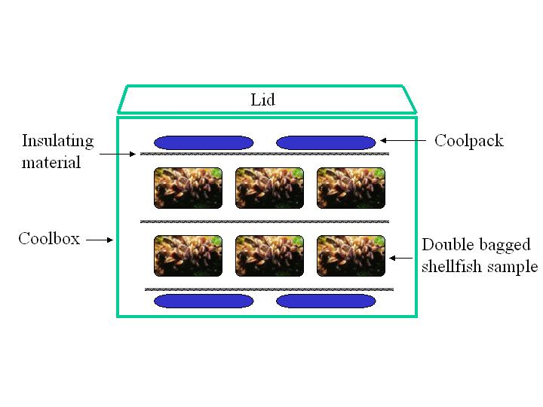
Figure 1. An example cool box packing arrangement

- Samples of shellfish should be collected as described in the sampling protocol.

- Samples should then be placed inside a food grade polythene bag, which, in turn, should be placed inside another bag to prevent leakage. This should then be completely wrapped in newspaper (or other insulation medium such as foam or bubble wrap) and placed inside the cool box between 2 layers of pre-frozen cool packs. The sample(s) should be surrounded by cool packs including a layer above and a layer below. Each layer should cover the breadth of the box and not allow room for the sample to become 'exposed'. Samples should not be frozen or placed in direct contact with ice packs. A layer of insulation material should be placed between the samples and cool packs.

- The pre-printed sample information sheet (see sample protocol) should be completed and placed inside a polythene bag and secured within the box.

- The lid should be secured in place with tape and the cool box then delivered to the test laboratory to arrive in time to allow testing to commence within 48 hours of sample collection.

Coolboxes for which validation studies have been carried out

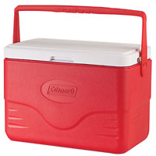

1. Coleman 28Q Model number 5278
Size: 51 x 27 x 35 cm
Material: Polypropylene
Capacity: 26.4 L

Used with 4 x 1000g ice packs. The 4 x 1000g ice packs firstly frozen to –18°C for at least 24 hr. and then placed in the appropriate positions within the box, 2 in the base of the box and 2 attached by the special clips to the cool box lid.

Validation by Preston Public Health Laboratory

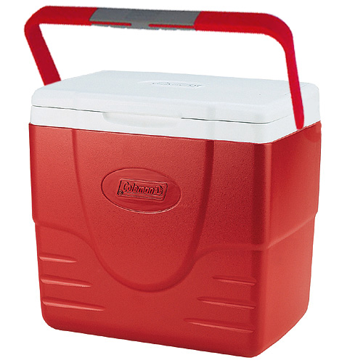
2. Coleman 16Q Excursion
Size: 14" x 15" x 9.5"
Capacity 15L
Material: Polypropylene

Used with 6 x Camping Gaz M10 ice packs (3 on top, 3 on bottom) with 1kg shellfish sample.

Validation by Integrin/Food Standards Agency Scotland

Packing arrangement:

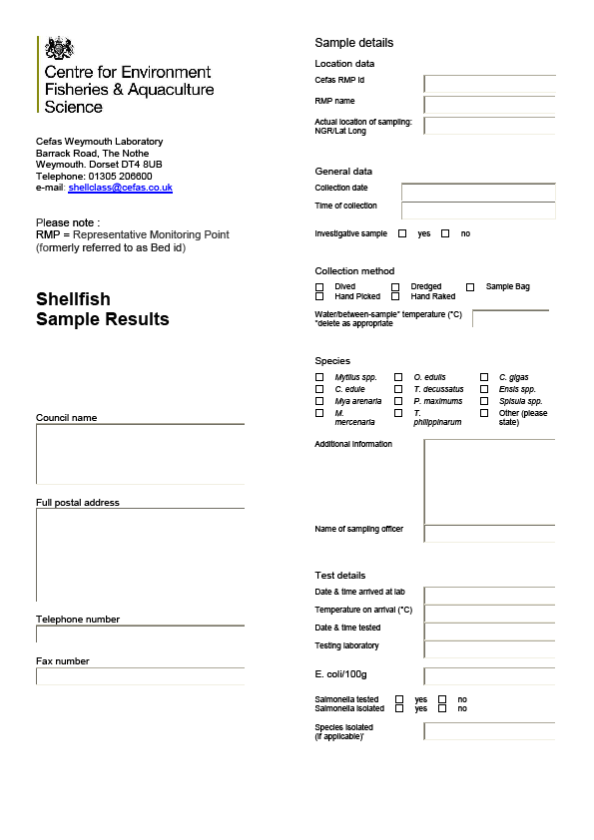Appendix B – Sample sheet
Bottom Layer of 3 ice packs
Sample in polythene bag
Layer of foam
Top Layer of 3 ice packs
Top 2 layers of foam

