Bivalve filter feeding shellfish species, such as oysters and mussels contaminated with certain pathogens can cause human illness. European food safety legislation stipulates that live bivalve molluscs (LBM) are tested for E. coli to reduce this risk of illness. To establish the safety of LBM placed on the market, Food Business Operators (FBOs) must ensure that products meet the ‘end product standard’ set down in legislation (EC Regulation 2073/2005 - Microbiological Criteria for Foodstuffs).

The end product standard is:

- ≤230 E. coli/100g of flesh and intra-valvular liquid

- If multiple samples are tested in a batch, the acceptability of the batch is now a 3-class sampling plan with M (maximum) = 700 E.coli/100g.

- Absence of Salmonella in 25g

Background:

EC Regulation 2073/2005 sets out criteria for LBM testing. In this regulation there is scope to use alternative methods other than the reference methods by FBOs, (e.g. more rapid methods), as long as the use of these alternative methods provides equivalent results and have been validated accordingly. It should be noted that there is a formal framework for this validation. For more information please see EU legislative rules regarding food microbiology (Regulation (EU) 2017/625) and EN ISO 16140 (Microbiology of food and animal feeding stuffs) which cover this in more detail.

Currently, there are three validated methods for E. coli testing purposes in LBM. The reference method and two alternative methods which have undergone formal validation against the reference method:

- The Most Probable Number (MPN) method (or reference method)

- Impedance method

- Pour plate or colony count technique

January 2019
End product testing (EPT)

- The MPN method
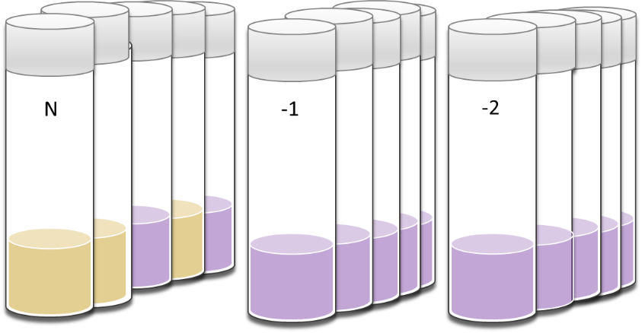
The MPN method is the most common test used to determine and quantify E. coli in LBM. The current reference method for the enumeration of E. coli in LMS (EN ISO TS 16649-3) is a two-stage, five tube by three dilution MPN method. This test relies on a statistical approach based on an estimation of the concentration of viable microorganisms in a given sample by replicate 10-fold dilutions, and assessing presence/absence in multiple subdivisions of that given sample (e.g. until a ‘negative’ is established). The MPN method is standardized and is a well characterized food testing method that is relatively simple to perform, provides easy to understand results, and can be used in a wide variety of laboratory settings. Many commercial food testing laboratories offer this method in the UK. The MPN approach is used internationally and is the method of choice for official control testing across Europe. It is the reference method for E. coli testing in bivalves specified in both Codex Code of Practice/Standard and in EU legislation. The method can determine levels of E. coli to very low levels (e.g. below end product standards), with a Limit of Detection (LOD) of <18/100g). A drawback of the method is that it usually takes 2 days to complete.
Five tube, three dilution primary incubation step of the MPN method, with 3/5 positive results (shown as yellow) in the N (neat) (1g) dilution, and no positive results in -1 (0.1g) and -2 (0.01g) dilutions. This tube combination, following confirmation, corresponds to a MPN of 80 E. coli/100g of LBM.

- Impedance method

The impedance method is based on the principle that E. coli growing in a selective culture medium produces metabolically charged end products (e.g. amino acids, organics acids, NH_{4,} etc.) that cause an impedance variation of the medium (e.g. a measure of the opposition of an electric current to the energy flow when a voltage is applied). This variation makes it possible to measure E. coli growth since it is proportional to the change in the number of E. coli present in the culture. The average quantification limit of the method is around 140 E. coli /100g LBM. There are a number of notable advantages and disadvantages to the impedance method. The method involves simple sample preparation which can significantly improve laboratory sample throughput, and a large number of samples can be tested simultaneously with impedance. The method is very rapid with results generated within 24h. Only a few laboratories in the UK provide impedance for LBM testing purposes as it’s an expensive technique to set up and use.

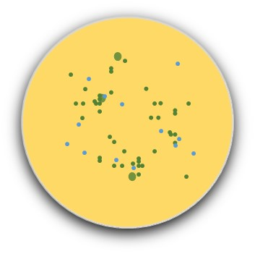
- Pour plate

Another alternative method used to enumerate E. coli in LBM is a pour plate, colony-count technique. This quantitative method involves diluting shellfish homogenate which is then mixed with a chromogenic (colour-changing) medium (e.g. TBX agar) in a sterile petri dishes and incubated at 37±1˚C for 4±0.5 hours (h) (resuscitation step). The inoculated TBX plates are then incubated (typically for 18-24h). E. coli is confirmed by the presence of blue/green colonies within the medium indicative of E. coli. There are advantages and also limitations to this technique. Firstly, it is simple and easy to establish in a laboratory, without the need for expensive equipment or set up costs. However, validation data suggests that the pour plate method is useful for determining E. coli between 200-18,000
Typical blue-green colonies of E. coli on agar plates which are counted as part of the pour plate testing approach.

/100g. This lack of sensitivity (200 E. coli) compared to the reference method may limit its uses for end product testing purposes. To our knowledge the method is also not used widely in the UK for shellfish testing purposes.

- Other methods

A number of other methods and techniques have been developed for determining E. coli in shellfish. These include petrifilm coliform methods, commercial techniques that use specialist media as well as advanced molecular approaches for the identification and quantification of E. coli in shellfish tissues. It should be noted that none of these methods have undergone formal validation against the reference method (MPN technique), however they can be used if appropriately validated according to internationally accepted protocols and their use authorised by the competent authority.

Critical considerations

Several important checks should be taken into account when choosing a test method for determining E. coli in LBM.

- It is recommended that the food testing laboratory undertaking the testing should be accredited for the methods used.
- It is imperative that the method used has a limit of quantitation less than the statutory limit for EPT (≤230 E. coli/100g of flesh and intra-valvular liquid).
- The results reported from the testing laboratory should be in a form where compliance with the statutory limit can be easily identified (≤230 E. coli/100g of flesh and intravalvular liquid, and M=700 if batches are tested), i.e. test results should be reported as E. coli per 100g of shellfish flesh and intravalvular liquid. If reports are not reported in this format it should be specifically checked whether the reporting limit enables compliance with a limit of ≤230 E. coli/100g of flesh and intra-valvular liquid.

